2021 Winner of the
Margolese Prize
Nina-Marie Lister

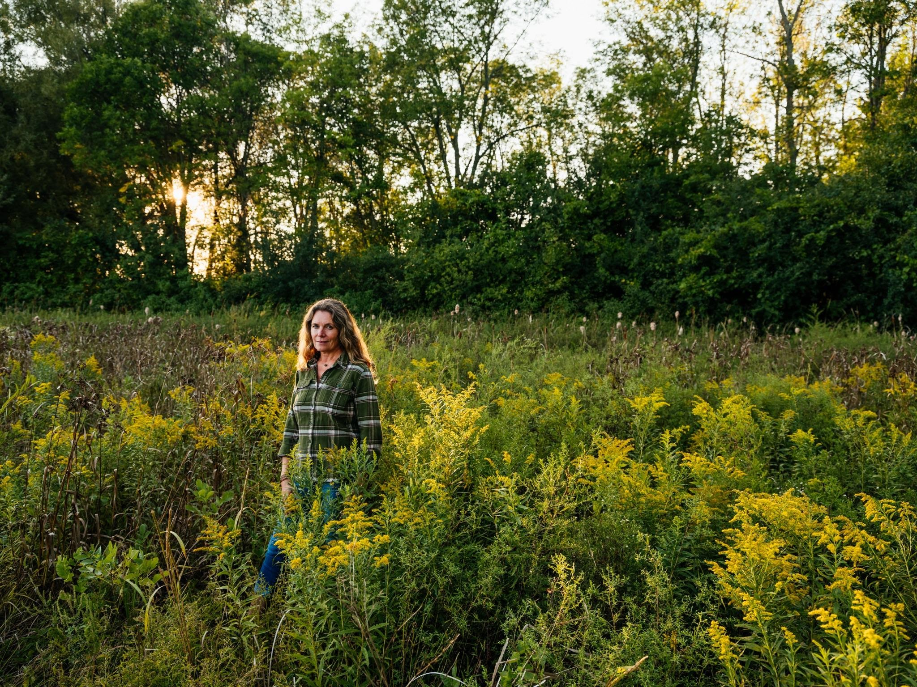
Photo credit: Johnny C Y Lam

Prof. Nina-Marie Lister
MCIP, RPP, Hon. ASLA

Nina-Marie Lister is an ecological designer and registered professional planner working across applied research, teaching and practice to connect people to nature in cities. Her transdisciplinary work advances designs for green infrastructure that protects biodiversity and supports equitable, accessible and healthy community-based solutions to the twin crises of climate change and biodiversity loss. Through design activism, she advocates for co-existence of wildlife and people in healthy, connected landscapes.

Lister is a Professor and Graduate Director at the School of Urban and Regional Planning at Ryerson University (renaming in process) in Toronto, where in 2006 she founded the Ecological Design Lab, Canada’s first hands-on community-based research incubator focused on applied urban ecology and design. Through the lab, funded by national research and foundation grants, Lister engages, trains and supports students working directly with professionals and communities to advance research and develop tangible solutions to complex, transdisciplinary problems such as climate resilience, urban biodiversity and human wellbeing.

Lister is a Senior Fellow of Massey College and was Visiting Professor of Landscape Architecture and Urban Planning at Harvard University, Graduate School of Design from 2010 to 2014. She will return to Harvard in 2022 to teach a graduate research course on (re)wilding landscapes. She is the editor of three books, including the highly-cited volume The Ecosystem Approach: Complexity, Uncertainty, and Managing for Sustainability, the ASLA-awarded Projective Ecologies, and the author of over one hundred scholarly research articles and professional practice publications.

As the founding principal of PLANDFORM, Lister engages in creative practice that emerges from collaboration across disciplines, working with ecologists, artists, landscape architects, engineers and planners to apply research and develop practices that support ecological design in urbanising landscapes to transition to climate-resilient communities. Through PLANDFORM, Lister collaborates on projects that are transforming the way communities think about and interact with the natural and built environments.

As a community leader, Lister serves as a member of the Waterfront Toronto Design Review Panel, Chair of the SSHRC Banting Post-Doctoral Fellowship Committee, and advisor to the international Biophilic Cities Network.

In recognition of her international leadership in ecological design, Lister was awarded Honourary Membership in the American Society of Landscape Architects and an inaugural Senior Fellow of the Society for Humans and Nature. She was named an “Inspired Educator” by the Canadian Green Building Council’s excellence and leadership awards and was nominated among Planetizen’s Most Influential Urbanists.

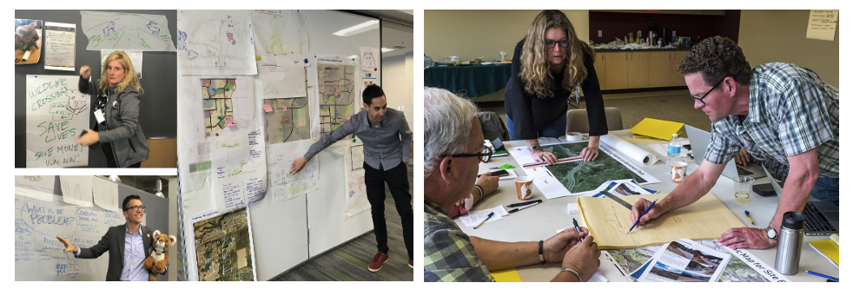
Photo credits: (L) Nina-Marie Lister, 2019 & (R) Marta Brocki, 2018
(Re)Connecting Landscapes: Green Infrastructure for People and Wildlife
Lister’s leadership was instrumental in the launch of ARC Solutions, an interdisciplinary partnership dedicated to reconnecting North American landscapes. The partnership grew out of the world’s first International Wildlife Crossing Infrastructure Design Competition (2010), directed by Lister, which engaged new thinking, methods, materials and solutions for wildlife crossing structures. Together with ARC partners, Lister has since led a series of design-research Collaboratories (CoLabs) to engage inter-professional design-based collaboration across architecture, engineering, transportation planning, ecology and art through applied research workshops providing creative space to experiment. The ideas, concepts, and proposals emerging from these transdisciplinary CoLabs are shaping the urban-wildlife interface at home and internationally. By leveraging the ideas and networks she developed at the Calgary Co-Lab, participant Beth Pratt (top left), Regional Executive Director of the National Wildlife Federation and the Liberty Canyon Wildlife Crossing team developed the innovative, landscape-integrated design for the $87 million project near Los Angeles.

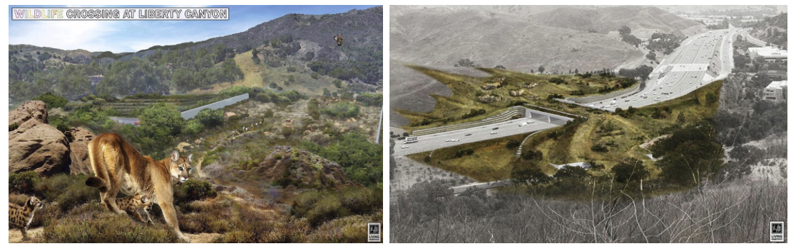
Image credits: Living Habitats, 2020
Safe Passage at Liberty Canyon
In partnership with Lister’s Ecological Design Lab, ARC Solutions was a catalyst for a federally-funded, multi-year international partnership grant involving 27 organizations across North America to create “safe passage” for humans and wildlife across roads. Through the Safe Passages project Lister developed integrated planning solutions and collaborative design research for next-generation wildlife crossing infrastructure. This work has resulted in several innovative wildlife crossing projects across North America, from fibre-reinforced plastic bridges to dual-use concepts for people and wildlife. Most recently, the project team contributed to the integrated design process for the world’s largest wildlife bridge, a “super crossing” in Los Angeles at Liberty Canyon, to provide safe passage for the endangered California Mountain Lion and other species at risk. This precedent-setting private-public partnership will provide a safe and sustainable passage for wildlife across 10 lanes of the Pacific US-101 highway and is scheduled to break ground in December 2021.
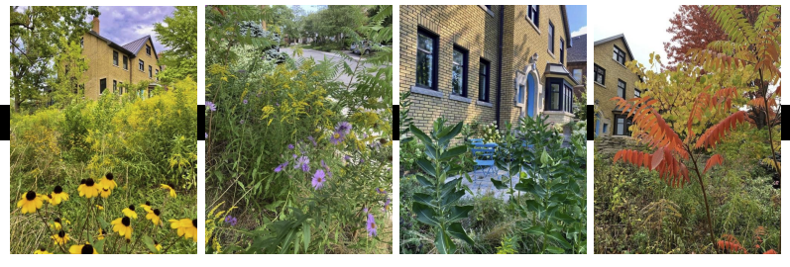
Photo credits: Nina-Marie Lister, 2020
Challenging Lawn Order: Biodiversity, Bylaws and the Biophilic City
Lister’s work bridges urban planning, landscape design, ecology, and activism. In 2020, the City of Toronto ordered Lister to cut down the garden in her front yard for violating the City’s “Long Grass and Weeds'' bylaw. Citing her defense of biodiversity, Lister refused and launched a year-long campaign of research and public advocacy. Designed and maintained as a meadow that is home to pollinating insects, bees, butterflies, moths, birds and mammals, Lister’s Hillcrest Meadow is populated with perennial plants and shrubs native to the Toronto area. Through her research with students at the Ecological Design Lab, her advisory roles with the City of Toronto, and public advocacy with local NGOs, Lister’s teamwork was instrumental in the 2021 revisions to the City’s bylaw, which now includes as-of-right natural gardens on private lands, connecting urban citizens to local landscapes and the biodiversity in their own yards.

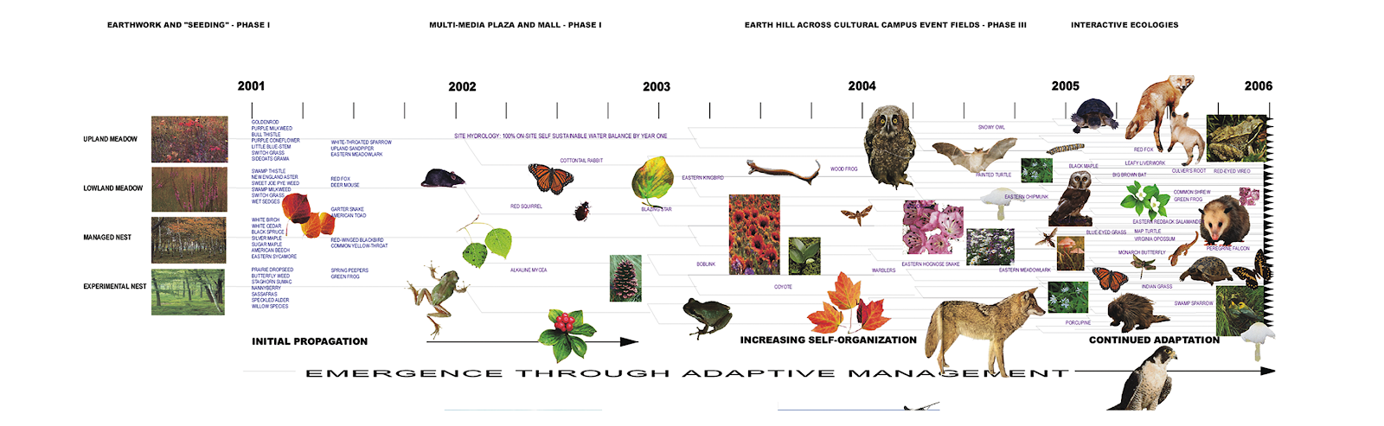

Image credit: James Corner & Stan Allen with Nina-Marie Lister, 1999
A New Ecology: Emergence & Adaptation at Downsview Park

In 1999, an international competition was held to select an urban park design for Downsview Park, a 320-acre former military base in Toronto. Working in collaboration with James Corner / Field Operations and Stan Allen, Lister brought contemporary ideas in ecology into the competition. This image catalysed a shift in landscape representation, bringing complex systems thinking into the emerging discipline of ecological design. Through this image and its implications for design, Lister’s work went on to significantly influence—and become synonymous with—ideas of process, flows and emergence in landscape architecture in the early 21st century.

